*31%*

*Using your textbook, labs and the internet complete the following test in 4 hours or less. All code submitted must be your original work.*

[PART A - 100 pts] Write a GUI application that can search a bookstore’s inventory of books.

* + The user can search by author name (case insensitive)
  + The user can search by ISBN number
  + The user can perform a keyword search (on the name or description of the book)

**Program must store this table in parallel arrays and use appropriate loops.**

|  |  |  |  |
| --- | --- | --- | --- |
| **Name** | **Keywords** | **Author** | **ISBN-13** |
| The Great Gatsby | The story of eccentric millionaire Jay Gatsby and his pursuit of his lost love. | F. Scott Fitzgerald | 978-1847496140 |
| War and Peace | A fictional story about the 1812 French invasion of Russia. | Leo Tolstoy | 978-1400079988 |
| Moby-Dick | The story of a sailor’s relentless hunt for a white whale. | Herman Melville | 978-1503280786 |
| Hamlet | A Shakespearean tragedy about a young man coming home from college after the murder of his father. | William Shakespeare | 978-1973844402 |
| Pride and Prejudice | A comedic story of love and life in Old England. | Jane Austen | 978-0141439518 |

Create the following methods:

* **ShowBook()** accepts the index of a book and displays all the information about that book. (If the index is invalid, it should display error messages as shown.)
* **SearchByAuthor()** accepts the name of the author as a string, and returns the index of the book as an int.
* **SearchByIsbn()** accepts the isbn of the book as a string, and returns the index of the book as an int.
* **SearchByKeyword()** accepts a keyword as a string, and returns the index of the book as an int.

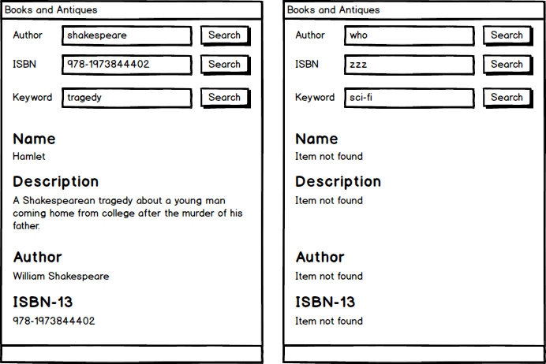

**Grading**

* Controls are laid out as displayed on mock-up diagram – **5 pts**
* Control names follow naming conventions – **5 pts**
* Variable names follow naming conventions – **5 pts**
* Method names follow naming conventions – **5 pts**
* Program stores book information in parallel arrays – **5 pts**
* User can search for a book by author name – **10 pts**
* User can search for a book by ISBN number – **10 pts**
* User can search for a book by keyword – **10 pts**
* Successful searches display all information about the found book – **5 pts**
* Failed searches display all expected error messages – **5 pts**
* Author name search is case insensitive and allows partial matches – **5 pts**
* Keyword search is case insensitive and allows partial matches – **5 pts**
* Keyword search looks at both the name and description of the book – **4 pts**
* **ShowBook()** method implemented as described – **4 pts**
* **SearchByAuthor()** method implemented as described – **4 pts**
* **SearchByIsbn()** method implemented as described – **4 pts**
* **SearchByKeyword()** method implemented as described – **4 pts**
* Return values from each custom method are used in the calling method - **5pts**